SOLANO COMMUNITY COLLEGE
MT 164, PROGRAMMABLE LOGIC CONTROLLERS
Spring, 2018

PLC PROGRAMMING LAB 5 - LOGIC GATES AND PLC PROGRAMS

Catharine Crayne
3/18/2018

OBJECTIVE:
- To write ladder logic programs based on logic gate circuits and boolean expressions.

GROUP MEMBERS
N/A

MATERIALS: Micrologix 1100 Trainer Unit, wires, RSLinx and RSLogix software, laptop, crossover cable.

SAFETY AND EQUIPMENT NOTES:
- Turn off trainer when attaching wires

PROCEDURE:
AND Logic:
- Wire up 2 NO pushbuttons and 3 lights on the PLC trainer and connect them to your PLC in appropriate locations.
- Write up a program that will perform 3 basic logic gate functions, AND, OR, and XOR, based on the 2 button inputs. The output of each function should be a different light. So that if button 1 AND button 2 are pressed, the green light will come on.
- Download the program and test it. Document it and write out the truth table for each.
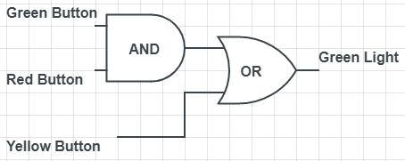
- Wire up an additional NO push button. Construct and test programs that evaluates the following logic situations. Document it, write out the boolean expression, and write out the truth table for each.
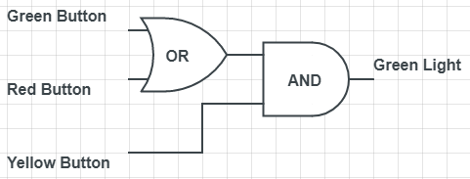

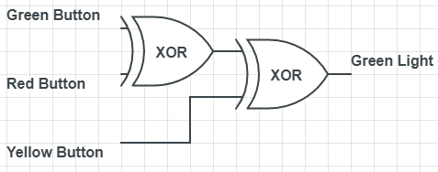
- Write a ladder logic program that will evaluate a 3 input XOR situation. Download it and test that it works. Write the boolean expression for it, document it and write out the truth table for it.

RESULTS - DATA
Step 2: Snapshot of our program.

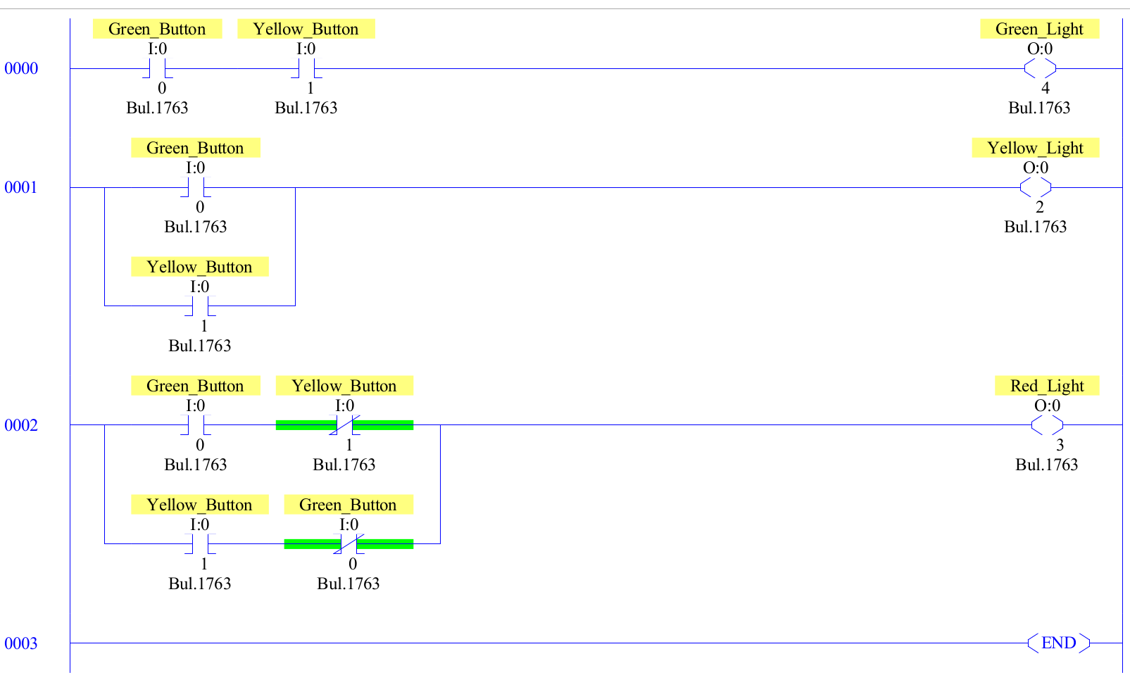

Step 3: Truth Table

AND
I:0/0 I:0/1 Value
1 1 1 (True)
1 0 0 (False)
0 1 0 (False)
0 0 0 (False)

OR
I:0/0 I:0/1 Value
1 1 1 (True)
1 0 1 (True)
0 1 1 (True)
0 0 0 (False)

XOR
I:0/0 I:0/1 Value
1 1 0 (False)
1 0 1 (True)
0 1 1 (True)
0 0 0 (False)

Step 4:

Boolean: Green_Light = Yellow_Button(Green_Button + Red_Button)

Green_Button Yellow_Button Green_Light

I:0/0 I:0/1 O:0/0

Red_Button

I:0/2

Truth Table

Red_Button Green_Button Yellow_Button Green_Light
1 0 0 0
1 1 0 0
1 1 1 1
0 1 1 1
0 0 1 0
1 0 1 1
0 0 0 0

Boolean: Green_Light = Yellow_Button + (Green_Button * Red_Button)

Green_Button Red_Button Green_Light

I:0/0 I:0/2 O:0/0

Yellow_Button

I:0/1

Truth Table
Red_Button Green_Button Yellow_Button Green_Light
1 1 1 1
0 1 1 1
0 0 1 1
0 0 0 0
1 0 0 0
1 1 0 1

Step 5:

Green_Button Red_Button Green_Light
I:0/0 I:0/2 O:0/0

Red_Button Green_Button
I:0/2 I:0/0

Yellow_Button Red_Button Green_Button
I:0/1 I:0/2 I:0/0

Boolean:
Green_Light = ((Green_Button Red_Button) Yellow_Button)

Truth Table
Red_Button Green_Button Yellow_Button Green_Light
1 1 1 0
0 1 1 0
0 0 1 1
0 0 0 0
1 0 0 1
1 1 0 0
1 0 1 0
0 1 1 0
0 1 0 1

OBSERVATIONS
Step 1: Picture of our setup
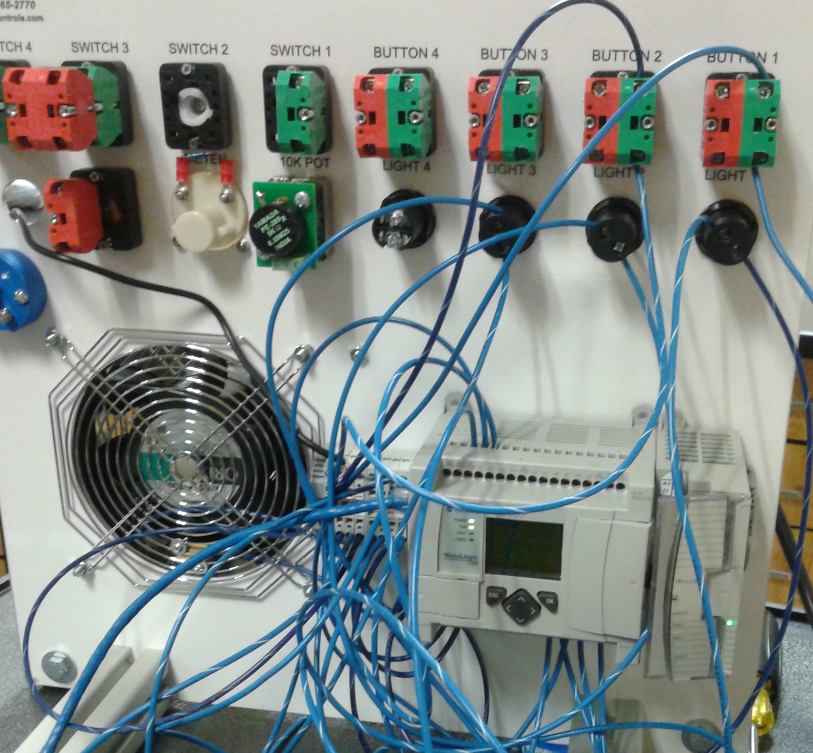

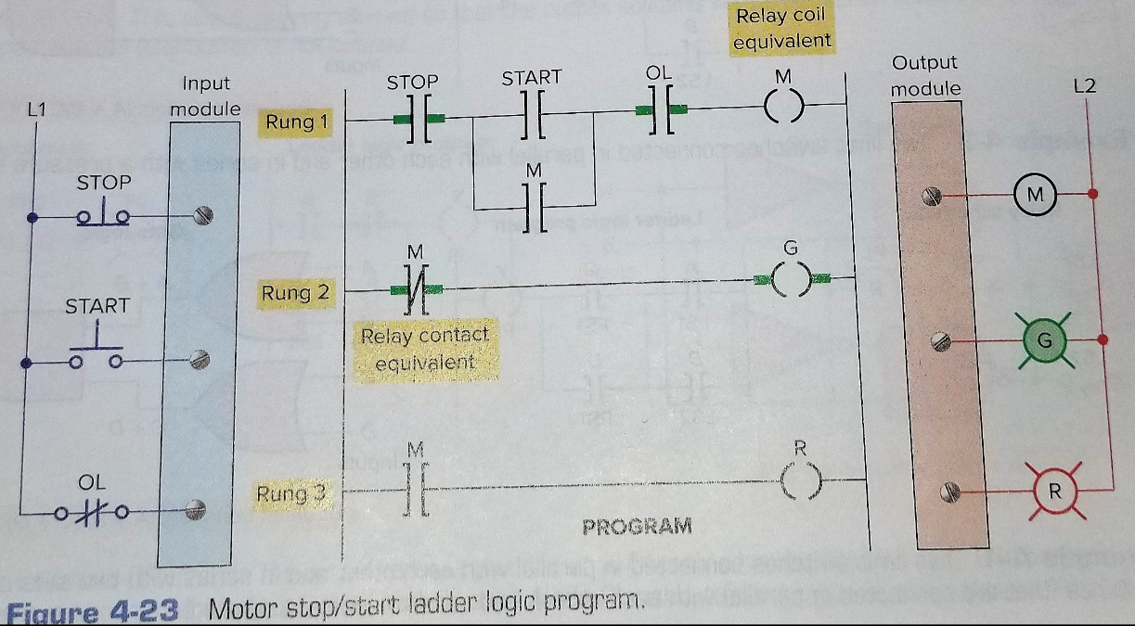
ANALYSIS QUESTIONS:
- How is a NOT gate represented in a ladder logic program?
Bold lines on either side of the gate.
- Examine the ladder schematic to the right (page 67). Write a logic gate circuit that corresponds to the first rung (3 inputs, motor is the output)

STOP

OL

M
START

M

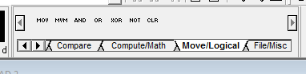
- Why are the logic functions found in the command library of RSLogix not useful for evaluating single bit addresses like switches and buttons? Data manipulation Instructions require words of data memory for operation, and a single bit address is not large enough for operation.

